# Learning about urban mitigation solutions

William F. Lamb, Felix Creutzig, Max C. Callaghan, Jan C. Minx

**Climate change assessments by the IPCC and others put increasing emphasis on cities as key actors in mitigation and early policy adoption. While a coherent understanding of barriers and opportunities for urban climate solutions remains fragmented, there is already a large body of case study literature to learn from and translate into different urban contexts** 1**. But a number of practical and conceptual challenges hinder systematic analysis. First, the literature tends to focus on cases in mega-cities or those in wealthy urban areas. By contrast, the majority of the global population resides in much smaller agglomerations, and most of the upcoming urban growth will occur in the Global South where infrastructures are only partially developed. Second, the researched solution space focuses on demand-side measures, but tends to overlook issues of urban form and infrastructure development in growing cities, even as carbon intensive consumption patterns are being locked into place. Third, comparative analysis of cases is sparse and systematic reviews of the literature are virtually non-existent. Given the large scope for learning between cities, but the challenges of generalising from individual studies, we propose a systematic blend of quantitative typologies with qualitative knowledge derived from cases to inform urban climate solutions.**

When it comes to urban mitigation solutions, the key questions are: what works, for whom, under what conditions, and why? Little progress has been made so far. With no consistent epistemology, enormous variety in boundaries of analysis, and a lack of formal research synthesis, urban mitigation solutions remain diffuse and under-exploited 2–4.

Systematic learning hinges on aggregating information about individual cities. Recent work emphasises a quantitative direction to this work, using ‘big data’ and typologies to identify structural similarities and path dependencies of development 5. Similar cities in this sense might draw from the same pool of solutions, or learn from successful examples of policy measures. To make this strategy actionable, however, it will be critical to complement quantitative typologies with an understanding of how underlying social and political conditions can shape or hinder urban transformations 6.

To this end, a sizable body of case study research exists for individual cities, as well as comparative studies across multiple urban settings 1. These cases often include a rich variety of contextual information on urban-scale projects and reforms, yet are not well represented in the scope of assessment literature on cities. The typical presentation of such evidence in assessment studies is predominantly of an anecdotal rather than analytical nature – in dedicated boxed sections, as examples of particular phenomena, or within curated libraries of initiatives. Above all, a lack of rigorous literature selection procedures in assessments (and in reviews generally) means that potentially relevant cases remain undiscovered – a hidden treasure that is increasingly buried under the exponential growth of publications 4.

Urban case studies can add to our understanding of climate mitigation solutions, but an overview of the field is urgently needed. Which cities do we know about? What topics do we know about? What comparative and secondary analysis is there of cases? And how can generalizable knowledge be derived from urban cases? In this perspective we address these questions, with a view to developing a more systematic agenda for aggregating knowledge on urban solutions. Overall we identify a rich and varied case study literature, albeit one with regional and topic biases, and a distinct lack of learning on these studies. We then propose an approach that blends quantitative and qualitative knowledge to inform urban climate solutions.

As a starting point to our analysis, we obtain a sample of urban mitigation articles using a search query that combines synonyms for “urban” and “mitigation” in the Web of Science and Scopus literature databases (see methods). Our interpretation of case study research is straightforward: if an article mentions a city name in the abstract or title, we assume it is a case study located in the city (or cities) mentioned. Our dataset for the proceeding analysis therefore consists of 3,440 publications, with meta-data on the cities they are situated in, the topics they investigate, their balance of review studies, and other information.

**Urban case studies are biased towards large cities and the global North**

Urban form and infrastructures shape energy use and greenhouse gas emissions on a time-scale of decades to centuries. With the window on 1.5°C rapidly closing it is hence essential to immediately initiate transformations in well-developed cities – and to guide emerging cities towards compact, low-carbon urban forms prepared for deep decarbonisation 7,8. Global urban population data suggests priorities: the largest segment of the world’s urban population currently resides in small Asian cities (SI Text Figure 1); while looking forward to 2030, the fastest urban growth will take place in Africa (SI Text Figure 2) 7,9. But it is unclear to what degree case studies reflect these priorities.

Figure 1 shows the spread of case study research across different city sizes, from a small number of familiar ‘mega-cities’ (over 10m inhabitants), to dozens of smaller national and regional capital cities (1-10m), and hundreds of yet smaller metropoles. The majority of research so far has focused on larger cities, with a small number of mega-cities receiving particular attention: Beijing (284 articles), New York (146), Shanghai (140) and London (117). Other cities are mentioned in fewer than 100 articles each.

The current focus on larger cities does not seem to be justified in multiple dimensions. Just 10% of the world’s urban population lives in mega-cities, compared to 40% in small cities – yet both groups are treated equally in research, each receiving approximately 20% of the case studies we find (Figure 2). A particularly stark divide can be seen in Asia, where the low proportion of mega-city inhabitants (10%) is served by over 40% of the urban case study literature in this region. Although mega-cities are fast-growing in most regions (SI Text Figure 2), this unbalanced focus leaves smaller urban centres consistently under-represented. This pattern is repeated for literature citations, with progressively larger cities receiving, on average, more citations (SI Text Figure 3).

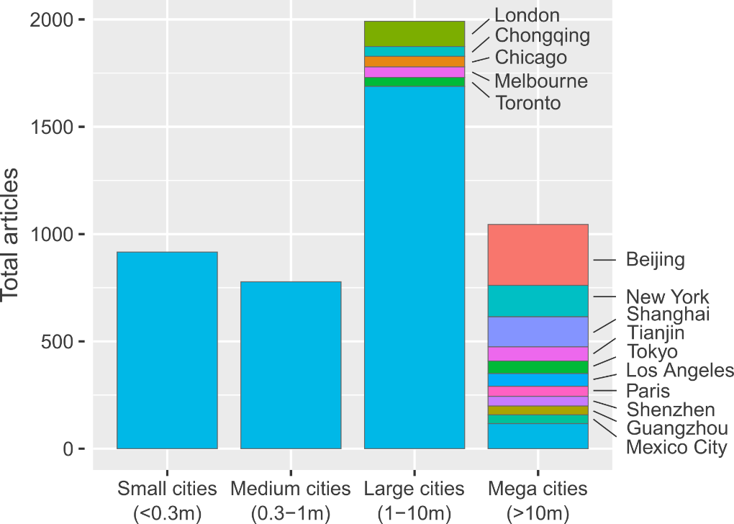

**Figure 1: Summed urban climate mitigation articles, grouped according to city size.** Where available, urban agglomeration data is used. The 15 most frequently studied cities are labelled.

Regionally, we observe a clear bias towards Europe, North America and Oceania, which receive an outsized share of articles relative to their small proportion of the global urban population (SI Text Figure 4). Looking forward to urbanisation trends in 2030, the least well represented region, Africa, has the fastest growing cities. And the least well represented segment, small Asian cities, will have the largest share of the global urban population. Hence, the world regions and city scales with most future relevance in terms of total urban population and growth dynamics are systematically underrepresented in the literature.

Arguably, the right focus for climate mitigation case studies is on high-emitting cities. We agree with this view, which, congruent with current debates on climate ethics 10, places the responsibility for drastic climate change mitigation action on the shoulders of the cities in the Global North. Nonetheless, the majority of future urban emissions will originate from Asian and African cities, where ongoing processes of urbanization and infrastructure development provide a window of opportunity for establishing urban designs that are consistent with low-carbon mode choices and building use19. Hence, a major shift in focus emerges as a clear priority for future research.

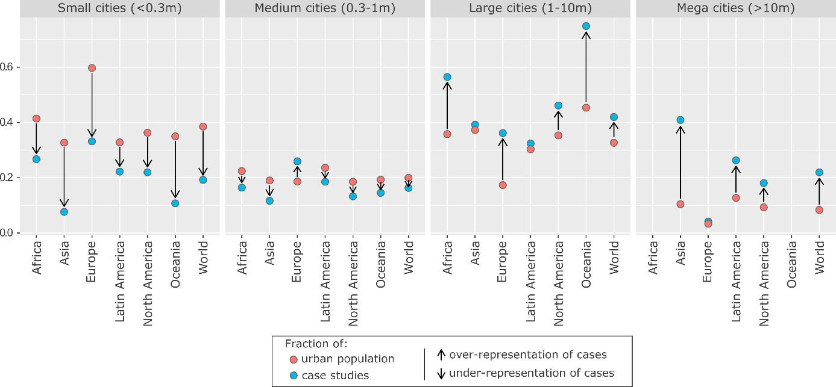

**Figure 2: Size bias in urban mitigation case study research.** Fractions of population and case studies are relative to regions.

**Demand-side topics dominate urban case studies**

Energy demand reduction is increasingly seen as a crucial component of ambitious climate mitigation 11,12. Cities, as the site of everyday behaviours and practices, offer significant scope for shaping energy demand through infrastructures, land-use planning and bottom-up social change 13. We therefore see an important role for urban research in assessing demand-side solutions, not least from the perspective of trade-offs and synergies with broader sustainability issues and human well-being 14,15. Case studies may be well suited for this task, due to their rich contextual analysis and ability to integrate diverse quantitative and qualitative lines of evidence.

As it is increasingly difficult to track the development of rapidly growing scientific fields, we turn to natural language processing methods in order to uncover the scope of mitigation research carried out on cities. Using the identified corpus of 3,440 case studies we construct a matrix of documents and the words they contain (abstracts only), factorising to obtain the ‘topics’ that describe commonly co-occurring words across the document set (we subsequently refer to this as “topic modelling”; see methods). In essence, machine reading software discovers the latent topics that permeate the document set and categorises each document accordingly, substituting for the laborious task of reading and tagging each article by hand. The unsupervised ‘learning’ in this method also reduces subjectivity in one’s overall assessment of a body of literature.

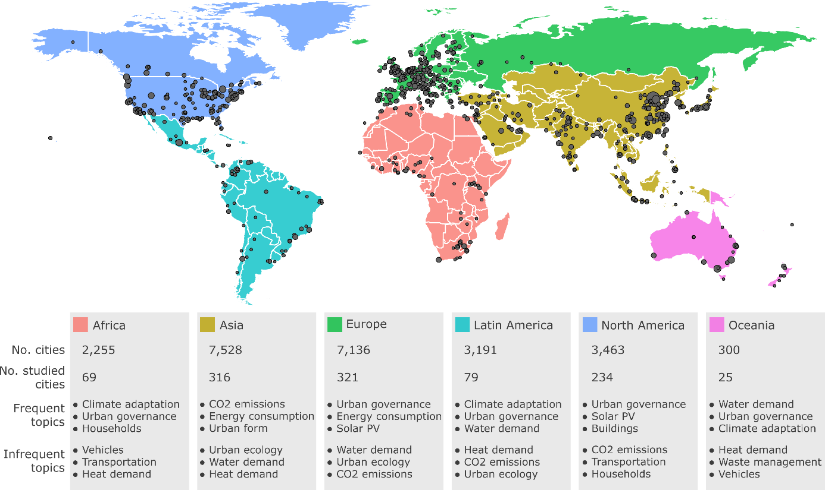

Figure : Urban case study cities and topics by region

We isolate 17 topics areas in the set of case studies (SI Text Table 1). Demand-side topics are prevalent, covering transportation, waste management, and energy and heat demand in buildings – alongside issues of urban governance, urban form and CO2 emissions accounting. A single supply-side topic emerges, solar PV. Wider sustainability issues such as air pollution, water demand, urban ecology and climate adaptation are also integrated in the case studies we identify.

As each case study document is marked up by a combination of these topics, the analysis can be scaled-up to groups of documents. Hence we can analyse prevalent (or lacking) topics at a regional level. Here we observe that emissions accounting and urban form are frequent subjects of case study research situated in Asia (Figure 3), reflecting a focus of R&D investments into engineering disciplines in China and South Korea and corresponding focus in education (44% of all students in China graduate in science & engineering, compared with 16% in the US). This contrasts with the ubiquity of urban governance research, which captures policies and policy-making, in all other regions. Climate adaption also emerges as the most prominent topic in Africa, Latin America and Oceania. As our search query specified no adaptation keywords, this latter result suggests a continued failure to balance urban adaptation research in these regions with a mitigation agenda.

Isolating research topics on individual cities is also possible. For instance we find that low-carbon transportation is scarcely researched for New York City and Chicago, but well developed for London (Table 1). Again, emissions accounting dominates the research landscape of top-tier cities in China (Beijing, Shanghai and Tianjin), while topics around urban ecology, water demand and waste management are overlooked here – at least in the mitigation focused literature we identify. SI Table 1 lists the articles we identify for the largest urban centre in Africa, Cairo, showing not just the scarcity of studies on this city, but the potential of topic modelling to rapidly identify the main themes of specific publications, in this case a predominant focus on building design and technologies.

|  |  |  |  |  |
| --- | --- | --- | --- | --- |
| **City** | **N. studies** | | **Frequent topics** | **Infrequent topics** |
| Beijing | | 284 | CO2 emissions; Energy consumption; Air pollution | Urban ecology; Water demand; Waste management |
| New York City | | 146 | Urban governance; Buildings; Climate adaptation | Waste management; Transportation; CO2 emissions |
| Shanghai | | 140 | CO2 emissions; Energy consumption; Urban form | Urban ecology; Water demand; Waste management |
| London | | 117 | Urban governance; Transportation; Climate adaptation | Water demand; Waste management; Green roofs |
| Tianjin | | 66 | CO2 emissions; GHG emissions; Energy consumption | Water demand; Urban ecology; Vehicles |
| Los Angeles | | 59 | Green roofs; Water demand; Air pollution | Waste management; Heat demand; CO2 emissions |
| Tokyo | | 59 | Solar PV; Urban form; Climate adaptation | Urban ecology; Water demand; Households |
| Chicago | | 49 | Urban governance; Urban ecology; Climate adaptation | Waste management; Households; Transportation |
| Melbourne | | 49 | Climate adaptation; Water demand; Urban governance | Urban ecology; Vehicles; Heat demand |
| Paris | | 47 | Urban governance; Air pollution; Climate adaptation | Water demand; Urban ecology; Green roofs |

**Table 1: Frequent and infrequent topics in the 10 most studied cities**

In the context of current research needs, forward looking studies that anticipate lock-in effects and future mitigation bottlenecks are key to enabling urban contributions towards the Paris Agreement goals 8. It is perhaps significant, then, that we find no topic referring to scenarios or forward looking studies. We therefore search abstracts directly for relevant keywords (e.g. “scenario” or “2050”; see methods for more detail). The identified documents (333 in total) mainly emphasise emissions accounting, transportation and air pollution (SI Text Table 3). Urban form is less prominent, despite its centrality to emissions reductions on the decadal timescale. Africa is particularly under-represented, with just 2% of the regional literature taking a forward looking orientation (3 studies). This contrasts with dozens of forward looking studies in other regions, which on average make up 10% of the literature in each (SI Text Table 4).

The topic modelling applied here identifies a strong focus on urban demand-side and sustainability topics, but clear research needs for particular regions and cities going forward. These include diversifying the scope of mitigation topics in large Chinese cities and initiating a mitigation focus in African and Latin American cities, particularly a forward-looking focus. Not least, there may be opportunities for structured learning where well-developed literature streams exist for individual cities.

**Limited efforts to learn from case study evidence**

Urban research is inherently diffuse and rooted in specific geographies. Generating broader insight from individual cases is hence central to building a global urban science. Two specific approaches would support an effort to internationalise and consolidate leaning on urban solutions: comparative studies, which contrast two or more cases simultaneously and draw insight from their similarities or differences; and systematic literature reviews, which review or perform secondary analysis on the literature using structured, reproducible methods.

Comparative research is considered a strength of urban studies, albeit a locus of on-going debate. The epistemological value of North-South urban comparisons is widely discussed, for instance, as is the generalisability of highly contextual case studies 16. Our sample of documents suggests the urban mitigation community does not shy away from comparative research, but remains conservative in the number of cases compared. We identify 699 studies that refer to more than one city in the abstract (of 3,440 in the sample – approximately 20%). The majority of these studies (409) mention only two cities, with a steep decline to a few dozen studies on 5 or more cities (SI Text Figure 9).

Inter-regional comparisons are relatively rare. Figure 4 visualises the pairwise correlations of cities within abstracts, aggregating by region. Asian cities tend to be compared to other Asian cities, European cities to European cities, and likewise in North America. Comparative literatures based in Latin America, Africa and Oceania, on the other hand, are far less cautious and have higher fractions of international comparisons, although fewer total studies. Considering the total scope of the urban case study literature (3,440 studies), the subset that is comparative (699), and internationally comparative (202), is small.

Based on a random selection and review of documents, we find little justification for why particular cities are bundled together, beyond claims of contextual diversity. Although this decision may often be driven by pragmatic concerns (such as funding and research partners), scientific learning in the field presupposes a transparent discussion of comparative logics 17. For instance, comparisons might proceed from the observation that common structural (political, economic, or geographic) characteristics drive urban phenomena, leading to differing path dependencies in energy consumption, and hence a role for typologies in structuring learning between similar types of cities 5. Alternatively, ubiquitous urban problems have been observed across many types of systems, such as the nexus of health, transportation and pollution externalities arising from agglomeration 18. Where individual cities demonstrate progress on solutions, for example through land-use policies and active travel provisioning, the resulting ‘proof of concept’ can prove highly relevant indeed across the urban landscape 19.

Another key route towards learning is through literature reviews and urban assessments. Formal review methods – those that deploy transparent and systematic procedures for literature selection, quality assessment and synthesis – are the gold standard for generating a robust evidence base for policy 20,21. These consist of a wide spread of quantitative, qualitative and mixed formal review approaches that are well-documented in the health sciences literature 22. Again, however, we find limited progress on this front.

We search the original set of documents identified in our urban mitigation query (12,918 articles) for review articles, and identify just 10 studies that apply formal review methods (see methods). The majority of these studies are narrative reviews (Table 2): akin to a normal literature review, but proceeding from a transparent search and selection of literature. Quantitative synthesis methods are sparse, comprising a single meta-analysis of residential demand-response programs (ref) and two studies that extract and analyse quantitative information from literatures on urban ecosystem services (refs). We do not find a single study referring to formal *case study* review methods, such as qualitative comparative analysis, case study meta-analysis, or case surveys 23 – although there are examples of these methods being applied directly to urban data (but not to the existing literature) 24.

|  |  |  |
| --- | --- | --- |
| **Authors & year** | **Title** | **Method** |
| Li & Babcock 2014 | Green roofs against pollution and climate change. A review | Narrative review |
| Lwasa et al. 2014 | Urban and peri-urban agriculture and forestry: Transcending poverty alleviation to climate change mitigation and adaptation | Narrative review |
| Brands 2014 | Prospects and challenges for sustainable sanitation in developed nations: a critical review | Narrative review |
| Lwasa et al. 2015 | A meta-analysis of urban and peri-urban agriculture and forestry in mediating climate change | Narrative review |
| Kwan & Hashim 2016 | A review on co-benefits of mass public transportation in climate change mitigation | Narrative review |
| Garcez 2017 | What do we know about the study of distributed generation policies and regulations in the Americas? A systematic review of literature | Bibliometrics |
| Deng et al. 2017 | Co-benefits of greenhouse gas mitigation: a review and classification by type, mitigation sector, and geography | Bibliometrics and narrative review |
| Francis & Jensen 2017 | Benefits of green roofs: A systematic review of the evidence for three ecosystem services | Quantitative synthesis |
| Srivastava, Passel & Laes 2018 | Assessing the success of electricity demand response programs: A meta-analysis | Meta-analysis |
| Song et al. 2018 | The economic benefits and costs of trees in urban forest stewardship: A systematic review | Bibliometrics, quantitative synthesis, narrative review |

**Table 2: Formal reviews of urban climate change mitigation.** The minimum criteria for a ‘formal review’ is the systematic selection of literature via a database search. Some reviews (7,8,9) focus on non-urban issues, but derive important conclusions for scientific learning at urban scale, and thus should be included in the relevant literature base on urban-scale climate change mitigation. See methods for our identification procedure.

The dearth of formal reviews on urban case studies is consistent with the wider field of energy studies and climate change mitigation 4,21 – and unsurprising given the challenge of varied case study methods, locations and scales. Yet, at the very least, a greater focus on transparent literature selection is needed to avoid overlooking research, particularly the minority of studies on smaller cities and less comprehensively covered regions. As with the narrow scope of comparative urban mitigation research, limited progress on this front suggests major innovations are needed to stimulate learning on urban solutions.

**Towards learning about urban mitigation solutions**

In this perspective we survey the landscape of case studies on urban climate mitigation. We focus on the geographic and topic distribution of research to date, and assess progress on comparative studies and systematic reviews. 5 issues appear to stand in the way of learning in this literature domain. (1) A substantial and unwarranted bias exists towards studies on large cities, and studies situated in the global North. (2) Only a handful of studies exist on African cities. These tends to emphasise adaptation over mitigation, and fail to address future urbanisation challenges. (3) The literature on Asian cities is strongly focused on emissions accounting, and is not yet balanced by a focus on policies and sustainability issues. (4) The existing comparative research lacks international scope and tends to be under-justified on conceptual grounds. (5) Only minor attempts have been made at systematically aggregating urban case study research through formal review methods.

Our sample of studies captures some non-English language articles (180 in total), most likely ignoring many others; nor does it capture grey literature such as NGO reports. Nonetheless, these results resonate with calls to develop global urban solutions and ‘leave no city behind’ in scientific assessments 2,3,25. The use of bibliometric techniques and topic modelling show that it is possible to judge progress on these goals with reduced subjectivity, even as the quantity of studies rapidly grows. Scaling the analysis to individual cities, groups of cities, or regions provides a flexible means to track and review literatures in advance of AR6 and future urban assessments. These methods are also applicable to other areas of case study literature, including urban adaptation research 26 and land-use science 27.

Our systematic review and topic modelling reveals that case studies are dominated by demand-side issues, such as demand for heating, transport, and water, but much less on supply-oriented solutions. This contrasts with the majority of climate mitigation scenarios that focus on supply-side technologies in the energy and also transport sector. The higher spatial resolution of city-level analysis appears to coincide with higher resolution on end-users and their concerns, but less investigation of the role of supply-side technologies to realize city-level climate mitigation. This insight has inversely relevant implications for the study of demand-side climate solutions that will have their own chapter in the IPCC’s AR6 report 16. A comprehensive understanding of demand-side solutions will need to build extensively on urban case studies.

Nonetheless, several pre-conditions need to be met to make progress on urban solutions. There are clear research gaps on African cities and smaller cities in Asia. Locating research efforts, as well as stakeholder engagement and policy advocacy in these regions will be instrumental to avoiding lock-in and realising compact, low-carbon urban forms that can tackle the coming mitigation challenge 7,8. Where large bodies of research already exist for other locales, the literature scoping methods shown here could support the consolidation of existing work into systematic reviews, allowing for a shift in focus towards less studied topics and locations.

Above all, a culture of learning is needed in the field. From making individual case studies available for meta-analyses, to increased ambition in comparative research, to large scale reviews of the case study literature that apply formal methods. (…)

**Methods**

*Literature scoping*

A search query combining ‘urban’ and ‘mitigation’ synonyms was used in the Web of Science and Scopus to identify relevant documents (Table 3). As of March 2018 this search returned 12,918 documents (unconstrained by language or document type).

|  |  |
| --- | --- |
| Urban synonyms | Mitigation synonyms |
| ("urban*" OR "municipal" OR "city" OR "cities" OR "metropolitan") | (“Paris Agreement” OR “low carbon” OR "decarboni*ation" OR (“energy” OR “carbon” OR “CO2” OR “GHG” OR “greenhouse gas” OR “climat*”) NEAR/3 ("mitigation" OR "reduc*" OR "polic*" OR "governance")) |

**Table 3: Search query for urban climate mitigation literature.** The two strings are combined with an ‘AND’ operator and entered as a topic search in the Web of Science, and a title-abstract-keyword search in Scopus.

*Identifying cases*

To identify urban case studies we searched the abstracts of the queried documents for city names. We use the Geonames database of geographic locations, which aggregates national survey data, travel destinations and open sourced contributions. Cities with a population greater than 15,000 were considered. This narrows the document set to 3,440 studies that directly refer to a city in the abstract or title. Double counting where an article mentions multiple city names, we obtain 4,730 case studies on individual cities. We excluded the text “Paris Agreement” and “Kyoto Protocol” from abstracts to avoid false hits.

*Topic modelling*

We use the sklearn library in python 28 to process and produce a topic model from the 3,440 studies mentioning a city in the abstract. Weighting terms in each document by the inverse of the number of times they appear across the corpus (tf-idf), we apply non-negative matrix factorisation 29 to a matrix of documents × terms, to identify 17 topics. The resulting matrices, whose product approximates the document-term matrix, are used to label documents by topic and topics by term. Each topic is given a name manually, according to the words and documents associated with it.

*Future-looking case studies*

To identify case studies with a future-looking orientation (including for example, mitigation scenarios, or projections of urbanisation, land-use, or energy demand), we manually search for the following keywords within abstracts: “scenario” OR “2020” OR “2025” OR “2030” OR “2040” OR “2045” OR “2050”. A random selection and screening of these documents showed they were broadly in line with our expectations.

*Systematic reviews*

To identify systematic reviews of the case study literature we manually search the original document set (12,918 studies) for the following keywords: “ meta-“ OR “systematic review” OR “scoping” OR “narrative review” OR “qualitative comparative analysis” OR “QCA” OR “scientometric” OR “synthesis”. The results are hand filtered to exclude non-urban, non-mitigation and non-review articles.

1. Lamb, W. F., Callaghan, M. W., Creutzig, F., Khosla, R. & Minx, J. C. The literature landscape on 1.5°C Climate Change and Cities. *Curr. Opin. Environ. Sustain.* **30,** 26–34 (2018).

2. Acuto, M., Parnell, S. & Seto, K. C. Building a global urban science. *Nat. Sustain.* **1,** 2–4 (2018).

3. Acuto, M. & Susan, P. Leave no city behind. *Science (80-. ).* **352,** 873 (2016).

4. Minx, J. C., Callaghan, M., Lamb, W. F., Garard, J. & Edenhofer, O. Learning about climate change solutions in the IPCC and beyond. *Environ. Sci. Policy* **77,** (2017).

5. Creutzig, F., Baiocchi, G., Bierkandt, R., Pichler, P.-P. & Seto, K. C. Global typology of urban energy use and potentials for an urbanization mitigation wedge. *Proc. Natl. Acad. Sci.* (2015). doi:10.1073/pnas.1315545112

6. Grandin, J., Haarstad, H., Kjærås, K. & Bouzarovski, S. The politics of rapid urban transformation. *Curr. Opin. Environ. Sustain.* **31,** 16–22 (2018).

7. Karen C., S. *et al.* in *Climate Change 2014: Mitigation of Climate Change. Contribution of Working Group III to the Fifth Assessment Report of the Intergovernmental Panel on Climate Change* 923–1000 (Cambridge University Press, 2014). doi:10.1017/CBO9781107415416.018

8. Creutzig, F. *et al.* Urban infrastructure choices structure climate solutions. *Nat. Clim. Chang.* **6,** 1054 (2016).

9. UN DESA. *World Urbanization Prospects: The 2014 Revision*. (United Nations, Department of Economic and Social Affairs, Population Division, 2015).

10. Kartha, S. *et al.* Cascading biases against poorer countries. *Nat. Clim. Chang.* **8,** 348–349 (2018).

11. van Vuuren, D. P. *et al.* Alternative pathways to the 1.5 °C target reduce the need for negative emission technologies. *Nat. Clim. Chang.* **8,** 391–397 (2018).

12. Creutzig, F. *et al.* Towards demand-side solutions for mitigating climate change. *Nat. Clim. Chang.* **8,** 260–271 (2018).

13. Creutzig, F. *et al.* Beyond Technology: Demand-Side Solutions for Climate Change Mitigation. *Annu. Rev. Environ. Resour.* **41,** 173–198 (2016).

14. Lamb, W. F. & Steinberger, J. K. Human well-being and climate change mitigation. *Wiley Interdiscip. Rev. Clim. Chang.* **8,** 1–16 (2017).

15. Ahmad, S., Pachauri, S. & Creutzig, F. Synergies and trade-offs between energy-efficient urbanization and health. *Environ. Res. Lett.* **12,** (2017).

16. Storper, M. & Scott, A. J. Current debates in urban theory: A critical assessment. *Urban Stud.* **53,** 1114–1136 (2016).

17. Steinberg, P. F. Can We Generalize from Case Studies? *Glob. Environ. Polit.* **15,** 152–175 (2015).

18. Grubler, A. *et al.* in *Global Energy Assessment - Toward a Sustainable Future* 1307–1400 (International Institute for Applied Systems Analysis and Cambridge University Press, 2012).

19. Sallis, J. F. *et al.* Use of science to guide city planning policy and practice: how to achieve healthy and sustainable future cities. *Lancet* **388,** 2936–2947 (2016).

20. Berrang-Ford, L., Pearce, T. & Ford, J. D. Systematic review approaches for climate change adaptation research. *Reg. Environ. Chang.* (2015). doi:10.1007/s10113-014-0708-7

21. Sorrell, S. Improving the evidence base for energy policy: The role of systematic reviews. *Energy Policy* **35,** 1858–1871 (2007).

22. Kastner, M., Antony, J., Soobiah, C., Straus, S. E. & Tricco, A. C. Conceptual recommendations for selecting the most appropriate knowledge synthesis method to answer research questions related to complex evidence. *J. Clin. Epidemiol.* **73,** 43–49 (2016).

23. Newig, J. & Fritsch, O. *The case survey method and applications in political science*. **49,** (2009).

24. Nijkamp, P. & Pepping, G. A Meta-analytical Evaluation of Sustainable City Initiatives. *Urban Stud.* **35,** 1481–1500 (1998).

25. McPhearson, T. *et al.* Scientists must have a say in the future of cities. *Nature* **538,** 165–166 (2016).

26. Vogel, B. & Henstra, D. Studying local climate adaptation: A heuristic research framework for comparative policy analysis. *Glob. Environ. Chang.* **31,** 110–120 (2015).

27. Margulies, J. D., Magliocca, N. R., Schmill, M. D. & Ellis, E. C. Ambiguous geographies: Connecting case study knowledge with global change science. *Ann. Am. Assoc. Geogr.* **106,** 572–596 (2016).

28. Pedregosa, F. *et al.* Scikit-learn: Machine Learning in Python. *J. Mach. Learn. Res.* **12,** 2825–2830 (2011).

29. Lee, D. D. & Seung, H. S. Learning the parts of objects by non-negative matrix factorization. *Nature* **401,** 788–91 (1999).

# Supplementary information

## Additional Figures and Tables

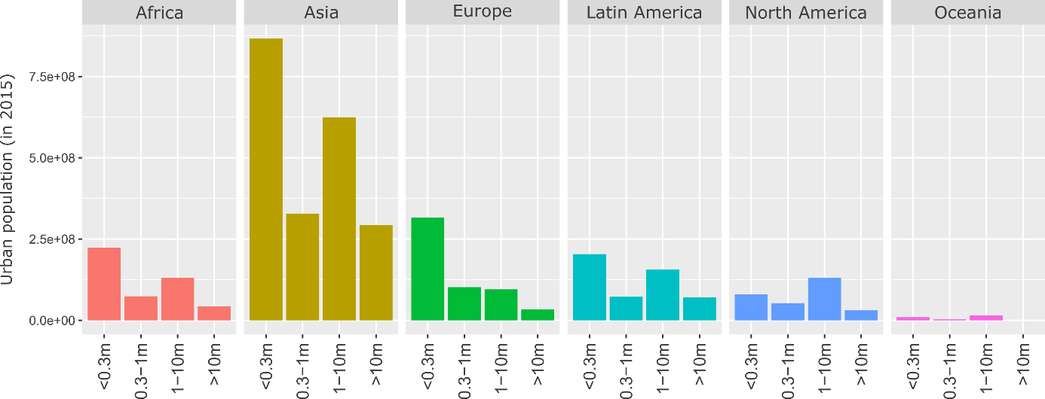

**Figure 1: Total urban population (in 2015) by region and city size**

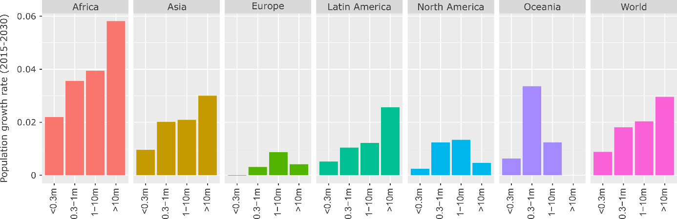

**Figure 2: Projected population growth rate by region and city size, 2015-2030**

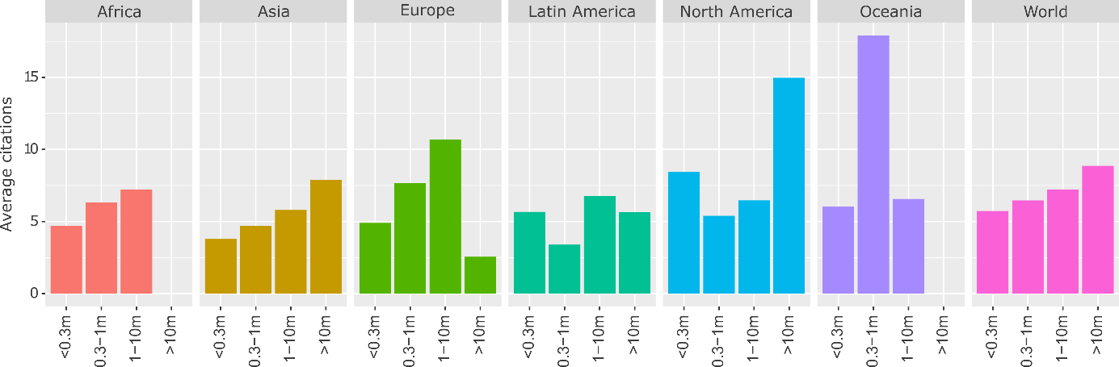

**Figure 3: Average citations of urban case studies by region and city size.** Citations are divided equally among cities in double-counted articles.

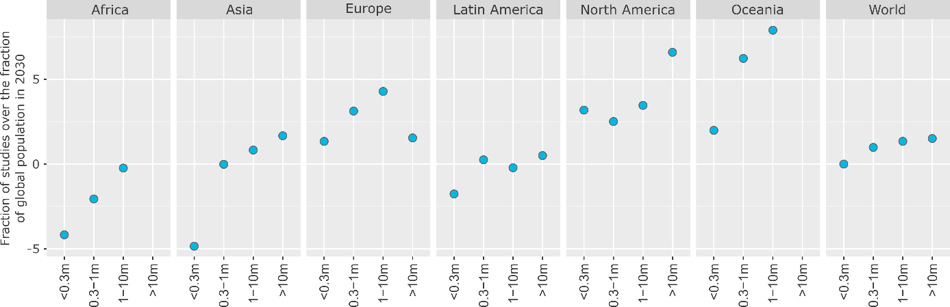

**Figure 4: The global distribution of urban case studies versus population**. To normalise, where the numerator (% of global population in a region & city size) exceeds the denominator (% of case studies in a region & city size), we subtract the fraction from 2.

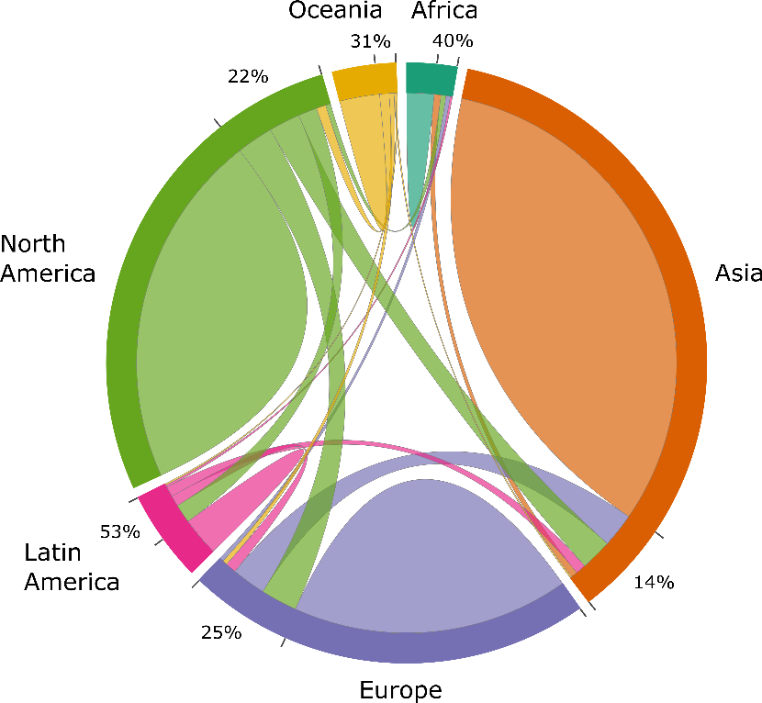

**Figure 5: Inter and intra-regional comparative research on urban climate mitigation.** Each link in the chord diagram is based on the pairwise coupling of two cities within a document. Documents where more than one city is mentioned in the abstract are used, totalling 699 studies. The proportion of regional couplings that pair with other regions (i.e. inter-regional urban comparisons) are indicated as percentages.

|  |  |  |  |
| --- | --- | --- | --- |
| **ID** | **Topic Name** | **Stemmed Keywords** | **Marginal Topic Distribution** |
| 1 | Urban governance | citi; polici; govern; local; develop | 9.3 |
| 2 | Energy consumption | energi; consumpt; effici; sector; beij | 7.9 |
| 3 | Urban form | urban; area; land; ecolog; model | 7.2 |
| 4 | Solar PV | system; solar; power; electr; energi | 7.0 |
| 5 | CO2 emissions | carbon; emiss; industri; china; lowcarbon | 6.8 |
| 6 | Buildings | build; design; energi; perform; residenti | 6.8 |
| 7 | Climate adaptation | climat; chang; adapt; risk; govern | 6.5 |
| 8 | Air pollution | air; pollut; health; qualiti; concentr | 6.2 |
| 9 | Transportation | transport; travel; traffic; public; car | 5.7 |
| 10 | GHG emissions | ghg; emiss; greenhous; gas; reduct | 5.4 |
| 11 | Vehicles | vehicl; electr; fuel; drive; emiss | 4.8 |
| 12 | Households | household; incom; electr; survey; hous | 4.7 |
| 13 | Waste management | wast; landfil; solid; manag; msw | 4.6 |
| 14 | Water demand | water; suppli; manag; demand; treatment | 4.6 |
| 15 | Heat demand | heat; district; thermal; demand; network | 4.6 |
| 16 | Green roofs | roof; temperatur; cool; green; surfac | 4.5 |
| 17 | Urban ecology | tree; forest; plant; speci; sequestr | 3.4 |

**Table 1: List of topics and their keywords**

|  |  |  |  |
| --- | --- | --- | --- |
| **Title** | **Year** | **Authors** | **Topics** |
| Energy efficiency strategies in urban planning of cites | 2009 | Khalil, H.A.E.E. | Urban governance; Energy consumption; Urban form |
| Active solar retrofit of a residential house, A case study in Egypt | 2010 | Attia, S., De Herde, A. | Buildings; Heat demand; Green roofs; Solar PV |
| Urban form, thermal comfort and building CO2 emissions - a numerical analysis in Cairo | 2011 | Fahmy, M, Sharples, S | Buildings; GHG emissions; Green roofs; Urban form |
| Effect of building form and urban pattern : On energy consumption of residential buildings in different desert climates | 2012 |  | Buildings; Urban form |
| Governing the transition to natural gas in Mediterranean Metropolis: The case of Cairo, Istanbul and Sfax (Tunisia) | 2015 | Verdeil, E, Arik, E, Bolzon, H, Markoum, J | Urban governance; Energy consumption; Heat demand; Urban form |
| Reducing cooling demands in a hot dry climate: A simulation study for non-insulated passive cool roof thermal performance in residential buildings | 2015 | Dabaieh, M, Wanas, O, Hegazy, MA, Johansson, E | Buildings; Green roofs |
| Assessment of building integrated photovoltaics for the residential section in representative Urban areas in Egypt | 2016 |  | Buildings; Energy consumption; Households; Solar PV; Urban form |
| High-rise buildings in context of sustainability; urban metaphors of greater Cairo, Egypt: A case study on sustainability and strategic environmental assessment | 2016 |  | Buildings |

**Table 1: Urban climate mitigation literature on Cairo**

|  |  |  |  |
| --- | --- | --- | --- |
| **Topic** | **Proportion** | **Topic** | **Proportion** |
| GHG emissions | 0.19 | Urban form | 0.08 |
| Transportation | 0.16 | Water demand | 0.08 |
| Air pollution | 0.16 | Waste management | 0.07 |
| CO2 emissions | 0.14 | Solar PV | 0.07 |
| Energy consumption | 0.12 | Households | 0.06 |
| Urban governance | 0.11 | Heat demand | 0.06 |
| Vehicles | 0.10 | Urban ecology | 0.05 |
| Climate adaptation | 0.10 | Green roofs | 0.04 |
| Buildings | 0.10 |  |  |

Table : Topic proportions of 'forward-looking' case studies

|  |  |  |  |
| --- | --- | --- | --- |
| **Region** | **No. case studies** | **No. ‘forward-looking’ studies** | **Fraction** |
| Africa | 175 | 4 | 0.02 |
| Asia | 1761 | 190 | 0.10 |
| Europe | 1207 | 129 | 0.11 |
| Latin America | 246 | 26 | 0.11 |
| North America | 1126 | 84 | 0.07 |
| Oceania | 184 | 19 | 0.10 |

Table : Regional coverage of 'forward-looking' case studies

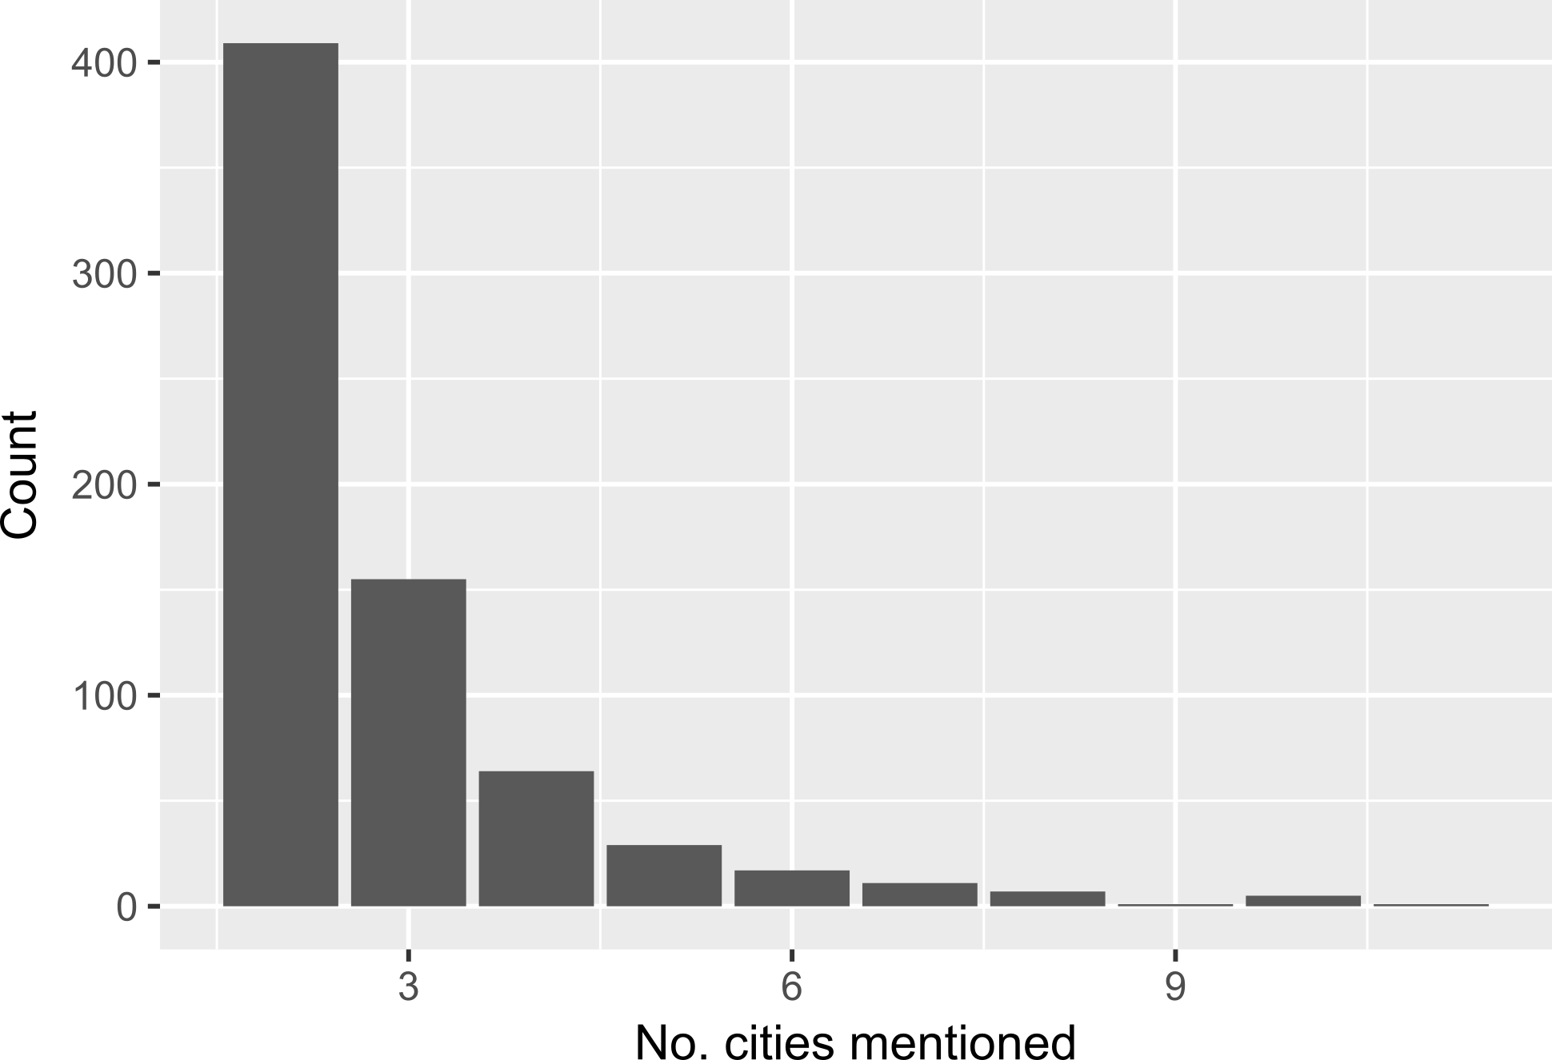

**Figure 5: Number of cities mentioned in comparative studies**